VoIP

Addressing QoS Beyond the
Provider Network

This White Paper explores the issue of voice

quality in VoIP networking and current status

of QoS technologies and implementations in

today’s IP networks. We discuss the QoS

mechanisms SmartNode™ employs to ensure the best-possible voice quality over the network-
access link.

Copyright

Copyright © 2006, Patton Electronics Company. All rights reserved.

Printed in the USA.

Introduction
Today’s Internet does far more then email and file transfers. Initially designed for non-real-time (NRT) data applications, the Internet has matured far beyond these tasks. In addition to web browsing, online imaging, and chat rooms, we now expect the Internet to deliver such real-time (RT) media as streaming music, video, and Internet phone calls directly to our homes and offices.

Presently, Voice-over-Internet Protocol (VoIP) is all the buzz—but it’s more than just talk. VoIP technology has matured. Not only is it the latest hot new Internet appli- cation. Today, VoIP has emerged as a reliable technol- ogy that is commercially viable, competing (and win- ning) against traditional phone services in business and consumer-class markets.

As a real-time application, VoIP—also known as packet voice, packet telephony, or IP telephony—places increased demands on the evolving Internet. VoIP users expect the Internet to deliver toll-quality voice with the same clarity as the traditional Public Switched Telephone Network (PSTN). To meet those expectations, the Internet connection must be more than merely reliable, it must be time-sensitive. Each and every voice packet must be delivered without significant delay and with consistent time intervals between packets.

Advanced Quality of Service (QoS) technology is the key
to achieving voice quality that measures up to today’s high standards. With SmartNode and Patton’s advanced QoS, toll-quality voice on every call is the benchmark.

Quality of Service (QoS)—In a successful VoIP deployment, the perceived voice quality of VoIP calls must satisfy user expectations. Specifically, voice quali-
ty in the VoIP system must compare favorably with that
of a traditional phone call. To ensure VoIP users hear
the best possible voice quality, Patton’s SmartNode employs a unique combination of varied QoS mecha- nisms. Network administrators can tune SmartNode’s QoS for optimal performance in a broad range of net- works giving packet voice the clarity and sound quali-
ty we expect on every call.

QoS and voice quality
From a technical perspective good voice quality involves minimizing delays and interruptions (“blips”) in the communication stream. For voice communications over an IP network, packet delays and losses in the VoIP network must be reduced to the levels of established benchmarks. To achieve a level of perceived voice quali-
ty that most users find acceptable, end-to-end packet delay must be reduced to a target of 120ms or less. In most IP networks some degree of packet loss may be inevitable. However, for a successful VoIP deployment, we must reduce packet loss to well below 1%. For Fax-over-
IP connections, the packet-loss target is especially critical.

Packet loss and packet delay may accumulate at multiple locations within the IP network. Every router, switch and transmission line is a potential culprit for har- boring these enemies of voice quality. Technology stan- dards such as TOS or DiffServ are designed to achieve the goal of establishing QoS in each and every node, thus enforcing QoS mechanisms throughout the network from end to end. (These standards will be discussed later
in this paper.) The reality today, however, is an Internet that does not differentiate between real-time (RT) and non-real-time (NRT) packets. As a result, VoIP networks require alternate methods for ensuring voice quality.

Addressing QoS at the edge of
the network
In VoIP systems that traverse the Internet, the bottleneck typically occurs at the access link—the low- bandwidth connection between the high-speed Internet- backbone (WAN) and the user network (LAN). Both net- works typically run at 100 Mbps or above. A typical access link may easily run about 200 times slower than the LAN residing in the home or office (say, 512 kbps for example). Congestion, queuing delay, and queue over- flows (resulting in dropped packets) are most likely to occur on this link. Depending on access-link bandwidth, packet size and burst size (the number of packets arriv- ing at once), queuing delay can be especially significant.

In a typical installation, a single access link serves both voice and data traffic, so special measures must be employed to ensure good voice quality. Consider the case of a 256 kbps access link from the Internet’s edge router to the user’s LAN. Suppose the Internet’s transmit queue contains five 1500-byte data packets, followed by one time-sensitive voice packet. It will take roughly 270 ms to send those data packets over the
256 kbps link. When the voice packet follows, it arrives with a delay longer than 120 ms (our target),
resulting in degraded voice quality.
Introducing class-of-service in the packet layer
addresses queuing delay by ensuring voice packets receive priority treatment—in much the same way that separate queues at airport check-in counters ensure pri- ority service to first-class customers. By creating separate queues for Real-Time and Non-Real-Time traffic, we can assign higher priority to the RT queue and serve that traf- fic with higher priority.

Upstream and downstream traffic present different problems, and are best addressed by different Quality of Service (QoS) mechanisms. Upstream traffic flows from the (home or office) user to the Internet, while down- stream traffic flows from the Internet to the user.

Implementing QoS in the upstream direction is relatively easy. SmartNode™ ensures that outbound voice packets get served before other packet types to prevent the Internet access link (the bottleneck) from becoming overloaded. SmartNode also provides tun- ing mechanisms for additional parameters like packet segmentation and overhead optimization, so network administrators can further fine-tune the upstream trans- mission for optimum voice quality.

Implementing QoS in the downstream direc- tion is more complex. Typically, customer-premise equipment (CPE) at user locations exerts no control

Figure 1. Internet Access
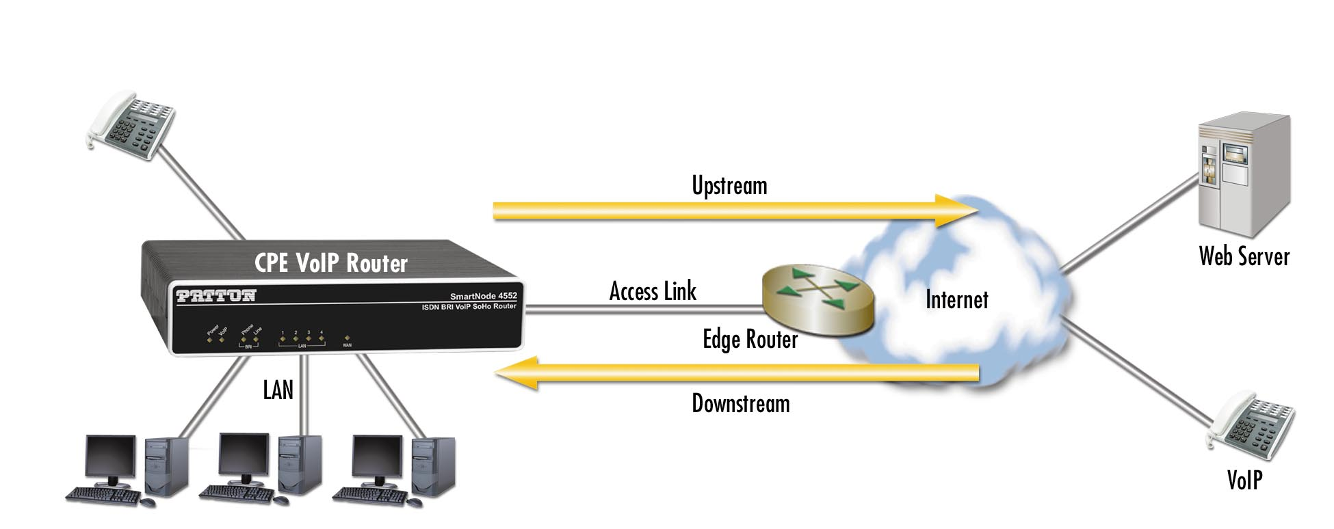

Figure 2. The Problem of Downstream Traffic
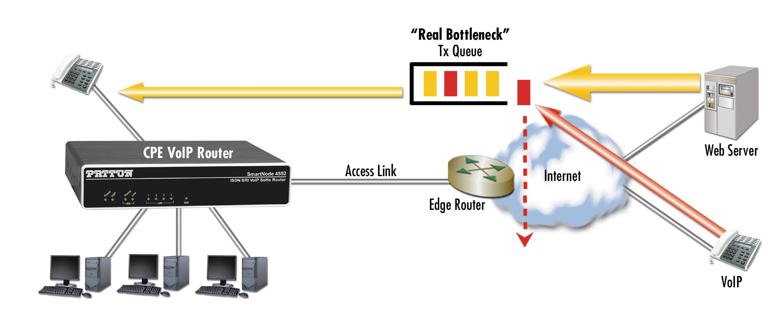

over incoming traffic. For traffic flowing downstream
from the Internet, the access router cannot control the volume nor the sending users. In addition, local users sharing the LAN with you can initiate file transfers or download their email at their convenience. The servers handling these requests may be located anyplace. Since the downstream rate normally cannot be con- trolled, the ISP’s edge router commonly responds to overloading by discarding VoIP packets with the same probability as any other packet type. These factors, or
a combination of them, may degrade voice quality to
a degree that users find objectionable. Data traffic, on the other hand, can be retransmitted so the impact on the user experience is simpler slower service response.

To resolve the problem of degraded voice quality for incoming traffic, Patton has devised a lead- ing-edge technology for SmartNode™ called DownStreamQoS™. Within the SmartNode deployed at the customer premise, DownStreamQoS dynamically creates a virtual bottleneck against the incoming pack-
et stream. This bottleneck can throttle back Non-Real-
Time traffic, preventing the edge router from blocking
or impeding voice traffic, to ensure voice packets are transmitted freely downstream. DownStreamQoS employs flow-control mechanisms within the TCP stan- dard to create the bottleneck. Because 80% of Internet traffic is transported via TCP, DownStreamQoS is espe- cially effective. The dynamic bottleneck adjusts to vary- ing traffic patterns. So whenever there are no VoIP calls
in progress, the full downstream bandwidth is available for incoming data such as file downloads.

Technology standards for QoS When implementing QoS to ensure good voice quality, VoIP networks may employ a selection of mech- anisms from a variety of standard communications pro- tocols. Such mechanisms may include:

• Tag or Label within the Packet or Frame

• Traffic (QoS) Classes

• Traffic (QoS) Conditioning or Packet treatment

Figure 3. SmartNode™ DownStreamQoS™
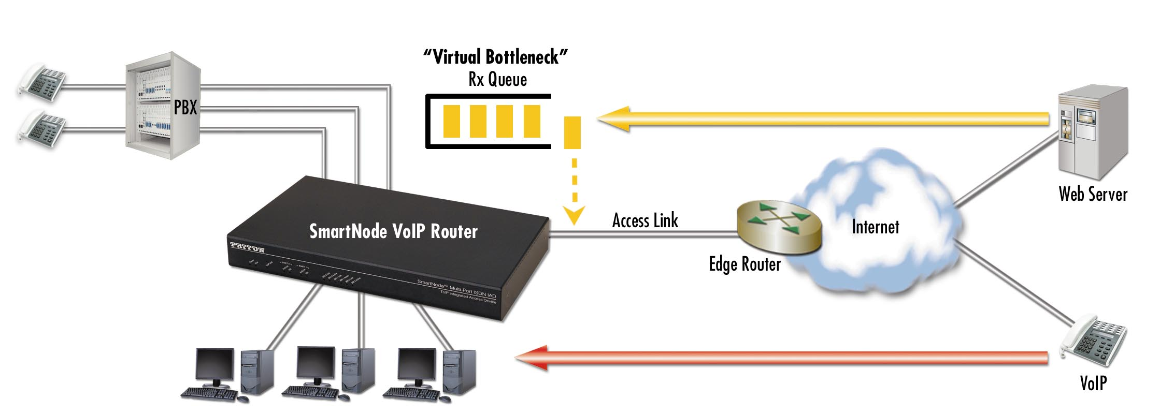

The table below summarizes the standard protocol
mechanisms Patton has employed in our unique imple- mentation of QoS for SmartNode VoIP solutions.

A key point to remember about any QoS-related standard is the following: a standard is only as effec- tive as its specific implementation in a specific net- work in the real world. For example, almost every router in the world claims to support TOS labeled IP packets. “So why,” we want to ask, “is the Internet still
a best-effort network? Why has the Internet not imple- mented QoS?” The answer lies in the additional com-
plexity of administering a network that delivers QoS.
A network operator who wants to offer different serv-

ice classes must do all of the following:

• Provide Service Level Agreements (SLAs) for the service classes offered (e.g. throughput guarantees or maximum delay values)
• Bill separate service classes individually

• Ensure that service classes are not fraudulently misused
• Dimension the network in a way so that SLAs for each service class can be met, even in fallback and redundancy scenarios

Standard

IEEE 802.1pQ
Layer

2 (Ethernet)
QoS Label

3 bits in Ethernet Header
Description

Extended Ethernet frame for VLAN and QoS.
Defines eight Priority Classes.

MPLS 2 (ATM, FR or Shim Label on IP) Not applicable Label switching protocol for core routers.
Can be used for traffic engineering, VPN
and QoS differentiation.

TOS/Precedence 3 (IP) 1 octet in IP Header Defines three traffic characteristics: low delay, high throughput, high reliability

DiffServ 3 (IP) Same octet in IP Header as TOS Defines a 6-bit field for service classes and
a number of Per-Hop Behaviors (PHB)
on how to treat packets

6

Administering a QoS network is much more com-
plex than ensuring reliable connectivity in a best-effort network. This complexity is why networks supporting dif- ferent service classes have not appeared until quite recently, and only a limited scale, and only from single operators. Considering the content of our discussion, one can begin to grasp the complexity of implementing QoS end-to-end across the boundaries of multiple networks.

Conclusion
The Internet Engineering Task Force (IETF) and the networking industry have defined a number of tech- nology standards and methods for offering levels of IP- network service that exceed the typical best-effort serv- ice levels currently available. Yet the reality today is that IP Networks—and the Internet in particular—con- tinue to lag behind in implementing these existing tech- nologies in order to deliver QoS to subscribers. The reason for the delay lies in the substantial complexity involved in administrating a QoS network.

SmartNode has implemented QoS mecha- nisms that significantly improve service quality for voice and data in a crucial section of the network— the subscriber access link. Further, SmartNode’s QoS mechanisms operate with complete independence from the Internet or wide area network. Finally, SmartNode is flexibly designed for future adapta- tion, ready and able to support leading QoS tech- nology standards as network providers begin to deploy them.
Today’s enterprises, carriers and service-
providers are eager to realize the cost-savings and flexibility of VoIP. Patton’s SmartNode™ family of VoIP solutions offers a complete line of VoIP Gateways and Broadband Internet Access Routers that deliver those cost and flexibility benefits now, while offering a smooth migration path to tomorrow’s fully-converged voice-data networks. Scaling from dual-port analog gateways up to Quad-PRI digital Gateway-Routers, all SmartNode™ models combine standards-based signaling (SIP, H.323 and MGCP/IUA) with advanced Patton’s feature-rich SessionRouter™ software to deliver robust Telephony- over-IP with industry-leading voice quality. SmartNode VoIP solutions integrate seamlessly with legacy communi- cations infrastructures to deliver end-to-end voice servic- es over any IP network. SmartNode™/SmartLink™ VoIP…more than just talk!

Key SmartNode features to make your VoIP project
a success:

• Standards Compliance—Protecting your investment in VoIP, SmartNode implements key industry standards for proven interoperability with third-party equipment and networks.
• Advanced Call Routing—SmartNode’s flexible SessionRouter software seamlessly integrates VoIP with existing telephony systems and numbering plans.
• Feature Transparency—SmartNode forwards PBX and PSTN features transparently to the user, preserving the benefits of advanced calling fea- tures in both traditional telephony and digital packet-voice networks.

7

Product Line
Series
Description

S-ATA

S-DTA SN41XX SN402X SN455X SN452X SN48XX SN463X SN465X SN1200/1400
Large Enterprises
Medium Enterprises
SN2350

SN2300

SN4900
Carrier

SN2450

SN2400
Residential Smart Analog Telephone Adapter

Residential Smart Digital (BRI) Telephone Adapter

Multi-Port Analog VoIP Gateway

Analog VoIP SOHO Router ISDN BRI VoIP SOHO Router Multi-Port Analog VoIP IAD
Multi-Port Analog IAD with Integrated WAN Access

Multi-Port ISDN VoIP IAD

Multi-Port ISDN VoIP IAD with Integrated WAN Access

ISDN BRI VoIP Gateway Modular VoIP Gateways Modular VoIP Routers IpChannel Bank
4-Slot Modular VoIP Gateways

4-Slot Modular VoIP Routers

Low Cost Analog
& ISDN Adapters

• Low Cost simplified VoIP Gateways
• Plug and Go Feature Set
• Two Models for both Analog and
ISDN Phones
• Single and Multiline with full
FAX support
Branch Office Routers
with VoIP

• SOHO VoIP with seamless connection to enterprise voice and fax
• Analog or digital options for one or two lines
• Network compatibility features allowing use virtually any IP service network with VPN, QoS, and Firewall features
• Single box LAN/WAN integration
Mutiport Analog & ISDN
with integrated WAN

• Small enterprise; branch/satellite office
• Voice extension and PBX voice and data
networking; any-access-to-any-network
• PSTN access with FXS and FXO and
FXS/FXO combinations; or ISDN BRI So
• Complete LAN/WAN routing with QoS,
VPN, and network integration for a sin-
gle-box solution

• Integrated WAN options for full routed

connections with PPP/Frame Relay
IpChannel Bank

• Analog trunking VoIP
• Multiport analog connections for call
centers
• Expansion slot for integrated WAN
uplinks using PPP/Frame Relay
• Reliability with redundant power and
redundant Ethernet
• Low to high density (from 12 to
32) analog ports



